Trees:

A tree contains a collection of nodes (also called vertices) where a pair of nodes are connected to each other with an edge. Unlike a graph a tree has no cycles (so it’s called acyclic).

In Trees We point the many other nodes

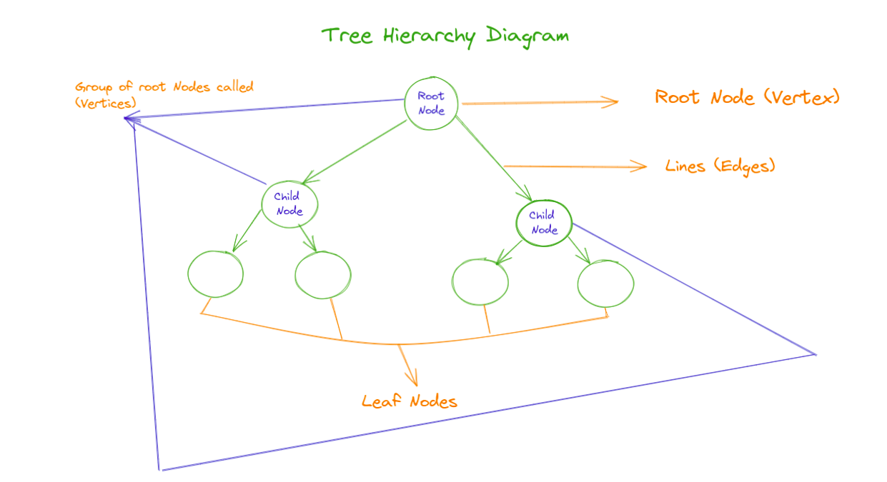

Examples of Tree Data Structure:
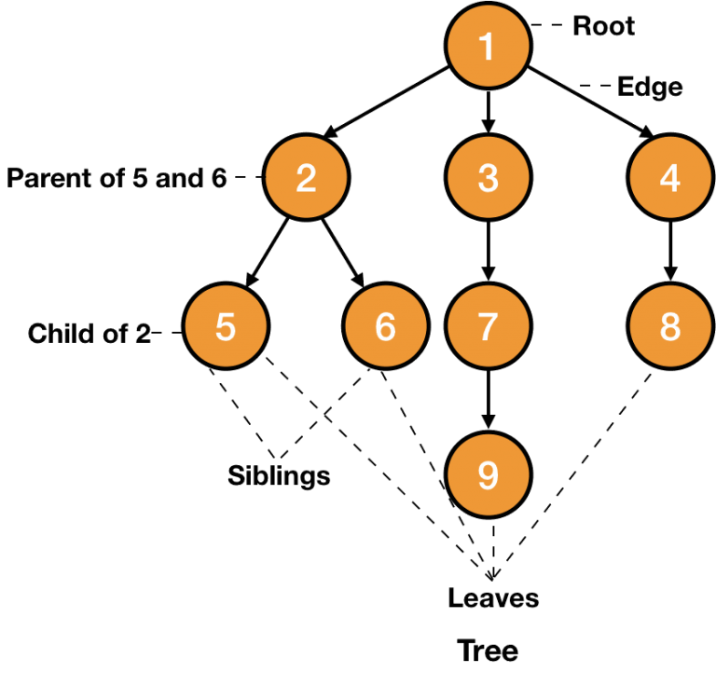

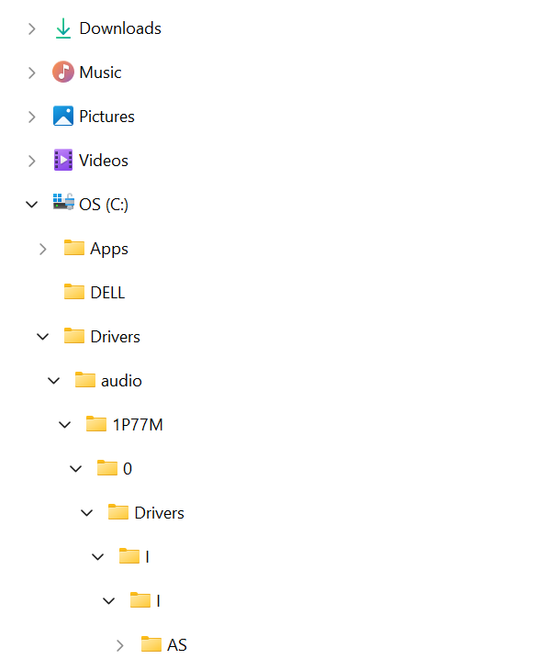

Tree Data Structure Terminologies:

Height:
Height of a tree is the length of longest path from root to leaf node. It is calculated with total number of edges

Depth:
Number of edges from the root node to that node is called the Depth of that node.
Depth of a tree = Height of tree – 1

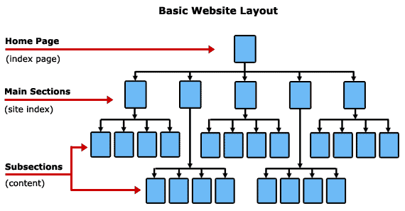

If suppose we want to use the tree means, we define some set of rules for the particuar tree.

At that time, we implement the set of rules in the tree means, it will form the different types of tress like binary search tree, avl tree.

Types of different data structures

Tries:

If we want to retrieve any data, that time we use this trie.

(Ex: Auto Complete, Auto message suggestions)

Heap

Heap in data structure, it is called only the binary tree

Types of Heap:

1. Min Heap
In the min heap, Root node has an only minimum value

2. Max Heap
In the max heap, Root node has an only maximum value

